KENDRIYA VIDYALAYA :: kond`Iya ivaValaya
SUMMATIVE ASSESSMENT – II
SUBJECT: E. V. S. ivaYaya: [-. vaI. esa.
CLASS: III kxaa: itsarI Time: 02 Hours
NAME : ____________________________________________________________________

SECTION : ______ ROLL NUMBER: ________ DATE: _______________
------------------------------------------------------------------------------------------------------------------------------------
OBSERVATION AND REPORTING

- Observe the pictures and answer the question that follow:

- Who is in the picture? What is he doing?
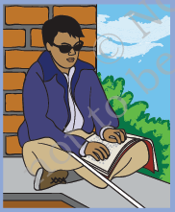

- Whose picture is this? What are they making?
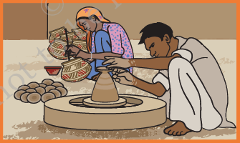

- What game are the children playing?
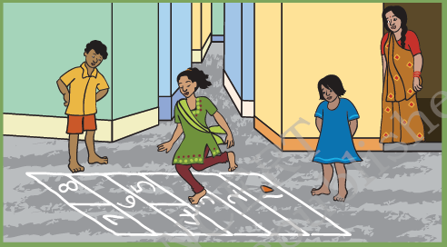

- What do you see in the picture? What is its use?
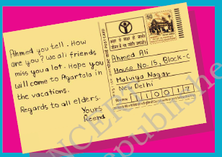

- What does the picture show? Where is it found?
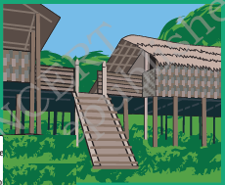

- What picture is here? Why is it crying?
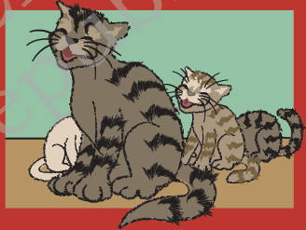

- Who are in the picture? How are they related to each other?
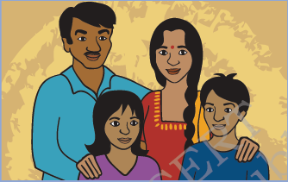

- Answer the following questions.

- Who all are there in Sitamma’s family?

Ans. ________________________________________________________________
________________________________________________________________
- Where do Madho’s mother and sister fetch water?

Ans. ________________________________________________________________
________________________________________________________________
- What things are available in a Post Office?

Ans. ________________________________________________________________
________________________________________________________________
- What is Braille Script?

Ans. ________________________________________________________________
________________________________________________________________
- What are the things that Chandu Dhobi does for his donkey?

Ans. ____________________________________________________________________
____________________________________________________________________
____________________________________________________________________
- Write why do we keep the following animals?

- Cow : It gives us milk.
- Dog : ___________________________
- Ox : ___________________________
- Hen : ___________________________
- Fish : ___________________________
- Honey bee : ___________________________
- Parrot : ___________________________
- Donkey : ___________________________
- Horse : ___________________________
- Elephant : ___________________________
- Goat : ___________________________

- Read the following list and write the appropriate word against each.

Phudgudi Bhanate Spinach Banana Pitcher Hospital
Snake and Ladder Igloo Telephone Amma and Nana

  - Leafy vegetable : ___________________________
  - Post Office : ___________________________
  - Crow : ___________________________
  - To speak to a friend in America : ___________________________
  - An indoor game : ___________________________
  - A fruit : ___________________________
  - Made of clay : ___________________________
  - A snow house : ___________________________
  - Sparrow : ___________________________
  - Tara : ___________________________

- Write five sentences about Sara and Habib’s family.

Ans. ____________________________________________________________________
____________________________________________________________________
____________________________________________________________________
____________________________________________________________________
____________________________________________________________________
____________________________________________________________________

- Match the words in Column ‘A’ with words in Column ‘B’.

Column: A |  | Column: B
High buildings |  | Delhi
Roofs of thorny bushes |  | Dal Lake
House boat |  | Assam
House on bamboo pillars |  | Family
Tauji |  | Rajasthan

- Put a ‘✓’ mark on the correct and ‘X’ mark on the wrong statement.

- Family members often live together in the same house. ( )
- We get turmeric from plant. ( )
- Kho – Kho is an indoor game. ( )
- Marker (thippi) is used to play football. ( )
- Pudina is used to cure cough and cold. ( )

- Do as directed.

- Write the names of four outdoor games.
- Write the names of four food items that we get from plants.
- What things are necessary to make a pot?
- Write four relationships in a family.
- Write the names of the fingers of your hand.

- Read the picture and answer the questions.

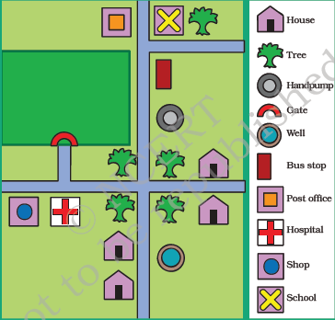

- How many houses are there in the map?

Ans.: ___________________

- How many shops are there in the map?

Ans.: ___________________

- How many trees are there in the map?

Ans.: ___________________

- How many pumps are there in the map?

Ans.: ___________________

- How many bus stops are there in the map?

Ans.: ___________________

